**CS2402 Assignment 3 Feedback**

**Marks: 100**

Good job. Please keep your hard work on. From a coding perspective there appears to be some aspects of the assignment that were overlooked or omitted:

**Question 1**

|  |  |  |
| --- | --- | --- |
| Marking Criteria | Full Marks | Your Marks |
| Structure of the recursive solution | 5 | 5 |
| Recursive calls logic | 5 | 5 |
| Function terminates correctly | 5 | 5 |
| Solution uses tail recursion design | 5 | 5 |
| Found largest intermediate value and steps required | 10 | 10 |
|  | 30 | 30 |

**Question 2**

|  |  |  |
| --- | --- | --- |
| Marking Criteria | Full Marks | Your Marks |
| employee Class Design | 5 | 5 |
| hourlyEmployee and salaryEmployee inherited from employee | 5 | 5 |
| Implementation of the virtual function in the class | 10 | 10 |
| Use of pointers/references to classes for run time binding | 10 | 10 |
| Generated reportPayHourly as specified | 5 | 5 |
| Generated reportPaySalary correctly | 5 | 5 |
| Found and listed top performers | 5 | 5 |
| Solved using the ‘+’ operator to find the total taxes | 10 | 10 |
| Overall design and OOP style of the solution | 10 | 10 |
| Documentation and Structure of the solution | 5 | 5 |
|  | 70 | 70 |

* Overall the output something like

Hourly Employee Pay Report

EmpID Name Pay Per Hour Hours Worked Pay For Week

201 Sam $35.00 47.00 $1767.50

202 Ann $27.00 38.00 $1026.00

205 James $45.00 22.00 $990.00

207 Samy $34.00 46.00 $1666.00

211 Bob $19.00 42.00 $817.00

212 Bill $17.00 19.00 $323.00

**213 James $18.00 34.00(22.0) $612.00(396)**

**214 Zoe $19.00 50.00(45.0) $1045.00(902.5)**

**215 Jill $19.90 12.00(11.0) $238.80(218.9)**

222 Marry $20.00 23.40 $468.00

313 Sammy $21.00 22.00 $462.00

314 Eve $22.00 45.00 $1045.00

315 John $21.50 11.00 $236.50

316 Herry $20.00 19.00 $380.00

317 Low $23.00 23.00 $529.00

**Total Pay Bill: $7775.89(7775.886=11605.8*0.67)**

**or $7522.36(7522.358=11227.4*0.67)**

**Total Tax: $3705.04**

**or $3829.92**

Salary Employee Pay Report

EmpID Name Pay Per Hour Perf Bonus Pay For Week

103 Joe $600.00 $200.00 $800.00

104 Jules $795.00 $250.00 $1045.00

106 Joanna $900.00 $0.00 $900.00

108 Silvia $3400.00 $1200.00 $4600.00

109 Chia $1200.00 $600.00 $1800.00

Total Pay Bill: $5029.75

Top Hourly Performers Report

Rank EmpID Name Pay Per Hour Hours Pay For Week

0 201 Sam $35.00 47.00 $1767.50

1 207 Samy $34.00 46.00 $1666.00

2 214 Zoe $19.00 50.00 $1045.00

Note: Both highlighted answers are acceptable because they are caused by typos in the provided work.txt file.

* Please pay attention to the following error(s):

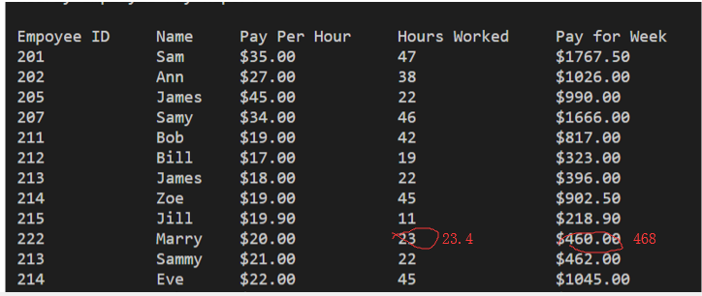

All the marking work runs on MinGW 8.1.0 in Windows. If you have any question or require any further clarification please contact me [Shuaifang.Wang@usq.edu.au](mailto:Shuaifang.Wang@usq.edu.au).

